**SU01: How to Create a New User in SAP**

Following are the detailed steps to Create a user in SAP

**Step 1)** Execute T-code SU01

[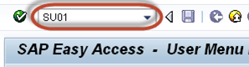](https://www.guru99.com/images/sap/2013/05/051313_1225_1.png)

**Step 2)**

1. Enter **Username** which you want to create.
2. Click the create button

[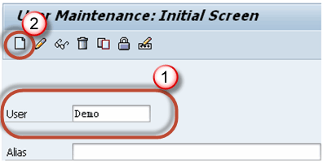](https://www.guru99.com/images/sap/2013/05/051313_1225_2.png)

**Step 3)** In the next screen

1. Click the **Address** tab.
2. Enter Detials

[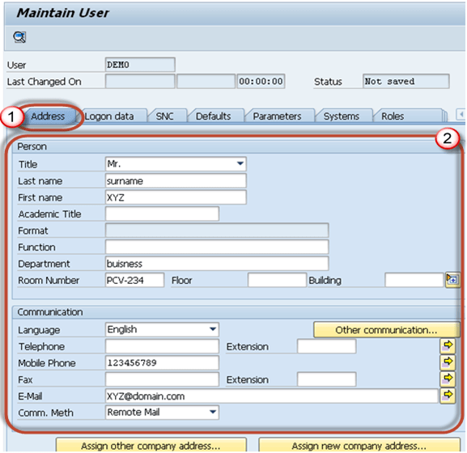](https://www.guru99.com/images/sap/2013/05/051313_1225_3.png)

**Step 4)** Choose the user type in **Logon Data** tab.  
  
There are 5 types of users in sap:-

1. **Dialog user**: - Normally it is used for interactive system access from GUI (used for human users)
2. **System user**: - Normally it is used for Background processing, communication within a system.
3. **Communication user**: - It is used for external RFC calls.
4. **Service user**: - Dialog user available to a larger, anonymous group of users.
5. **Reference user**: - General, non-person related users that allows the assignment of additional authorizations. Example, Internet users created with transaction SU01. No logon is possible.

[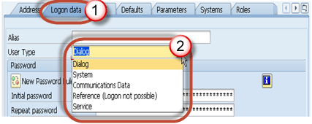](https://www.guru99.com/images/sap/2013/05/051313_1225_4.png)

**Step 5)**Type the **initial password** for 2 times.  
  
On first logon of the new user , system will ask to re-set the password.

[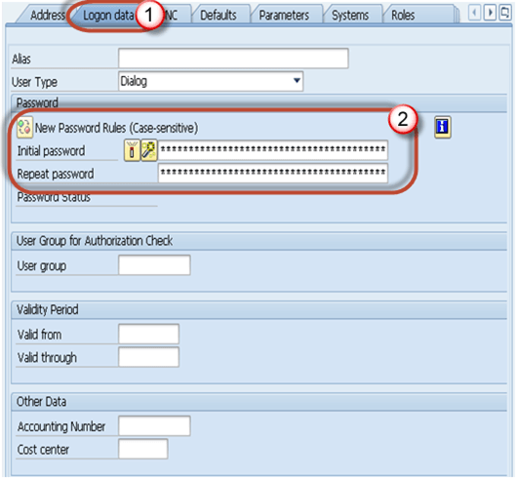](https://www.guru99.com/images/sap/2013/05/051313_1225_5.png)

**Step 6)**

1. Select the roles tab
2. Assign roles as per requirements

[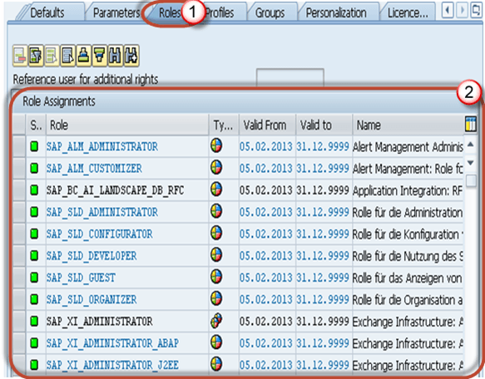](https://www.guru99.com/images/sap/2013/05/051313_1225_6.png)

**Step 7)**

1. Select the **profiles** tab
2. Assign profiles as per requirements

[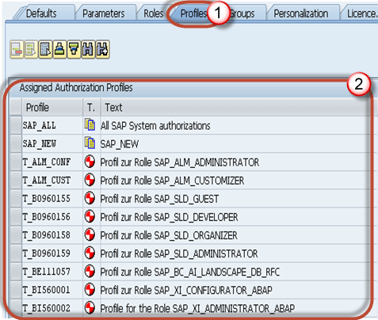](https://www.guru99.com/images/sap/2013/05/051313_1225_7.png)

You can assign **SAP_ALL** and **SAP_New** profile to user for **full authorization.**

* **SAP_ALL**:You assign this profile to users who are to have all R/3 authorizations, including super-user authorization.
* **SAP_NEW**:You assign this profile to users who have access to all currently unprotected components. The SAP_NEW profile grants unrestricted access to all existing functions for which additional authorization checks have been introduced. Users can therefore continue to work uninterrupted with functions which are subject to new authorization checks which were not previously executed.

**Step 8)**

1. Press **save**
2. Then the**back button (F3)** button

[SU01: How to Create a New User in SAP](https://www.guru99.com/images/sap/2013/05/051313_1225_8.png)

User will be created!